16082676
Hash Value Determination and Verification
The forensic image Image.E01 was analysed by uploading the file to Autopsy as Disk Image to determine and verify the hash values of the original disk in order to ensure the integrity and authenticity of the digital evidence.
Identification of Hash Values
The initial hash values obtained from the image metadata are:
- MD5: b267fb0cd94645425eee00258d3a9b58
- SHA-1: a1102c70a50768b588225fdcad6efa5d5d57341b
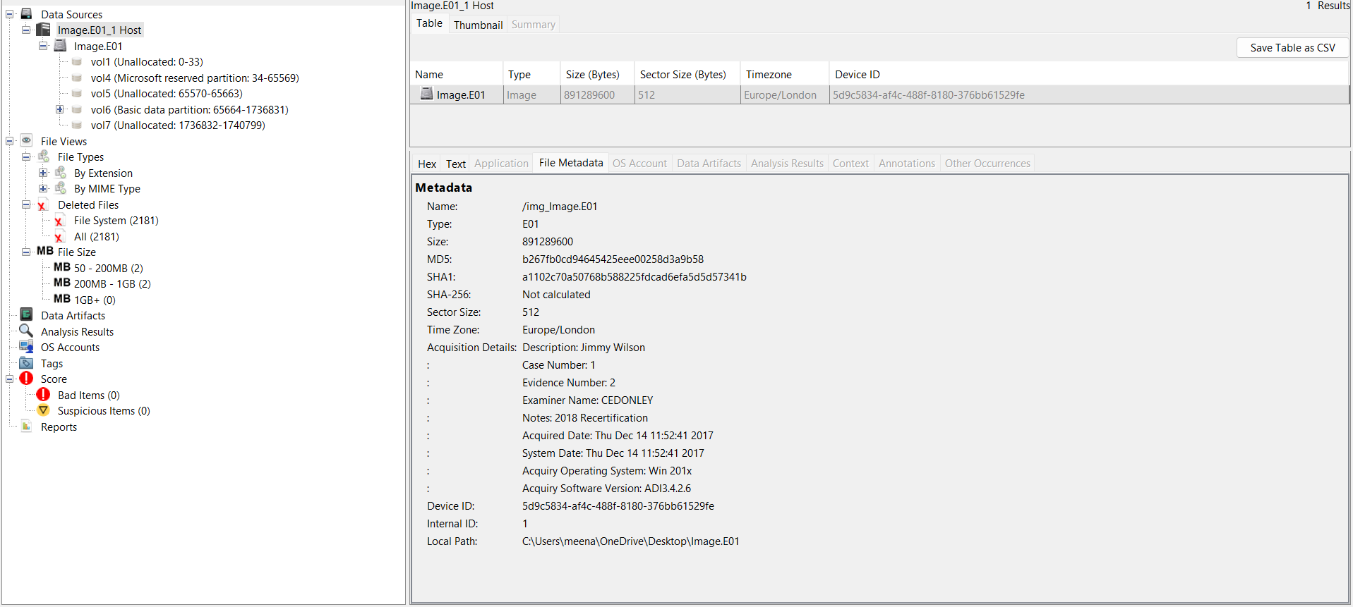
Figure 1 Data Source Summary
These hash values are embedded within the E01 forensic image and represent the original state of the acquired disk.
Verification Using Autopsy
To verify integrity, the Data Source Integrity module in Autopsy was used. The results verified:
- MD5 (Calculated = Stored)
- SHA-1 (Calculated = Stored)
This determines that the image is an exact bit-for-bit copy and has not been changed.
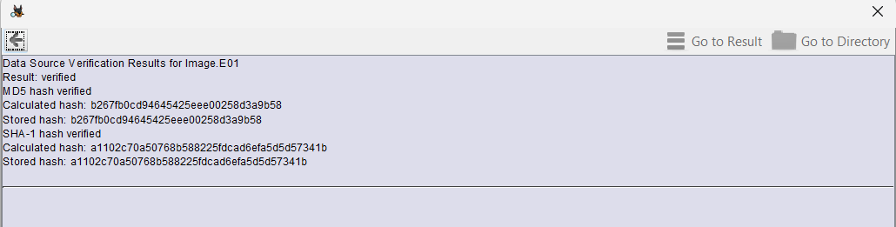
Figure 2 Data Source Verification Results
Verification Using AccessData FTK Imager tool
Additional validation was performed using FTK Imager, where both MD5 and SHA-1 hashes were successfully verified, producing matching results.
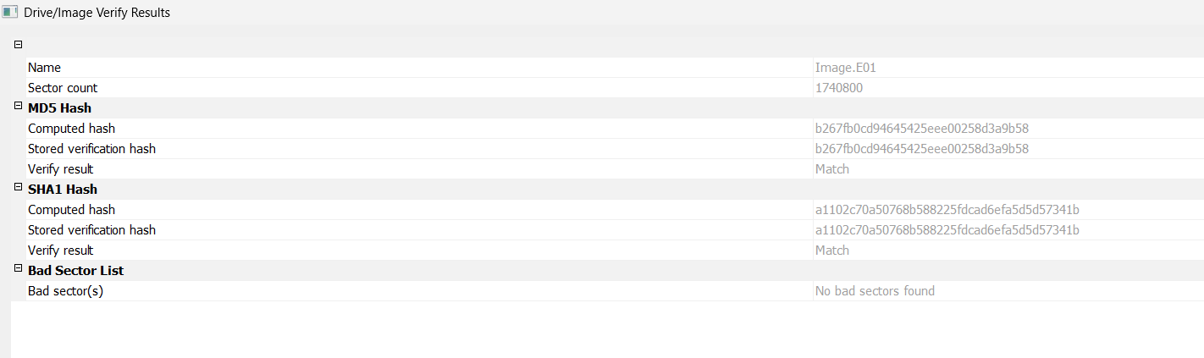
Figure 3AccessData FTK Imager Verification Output
SHA-256 is not stored within this E01 file. But verified using the PowerShell command.
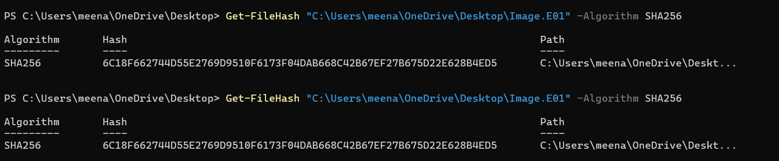
Figure 4 PowerShell SHA-256 Output
Conclusion
The hash values of the Image.E01 were successfully determined and verified using Autopsy and FTK tool. The matching MD5 and SHA-1 hashes confirm the integrity of the evidence.

Disk Size
The image disk size is identified as 891,289,600 bytes, which is 891.29 MB from the file metadata. This correspond to the total size of the acquired disk image.
This value is typically shown directly in forensic tools such as Autopsy when the image is loaded.

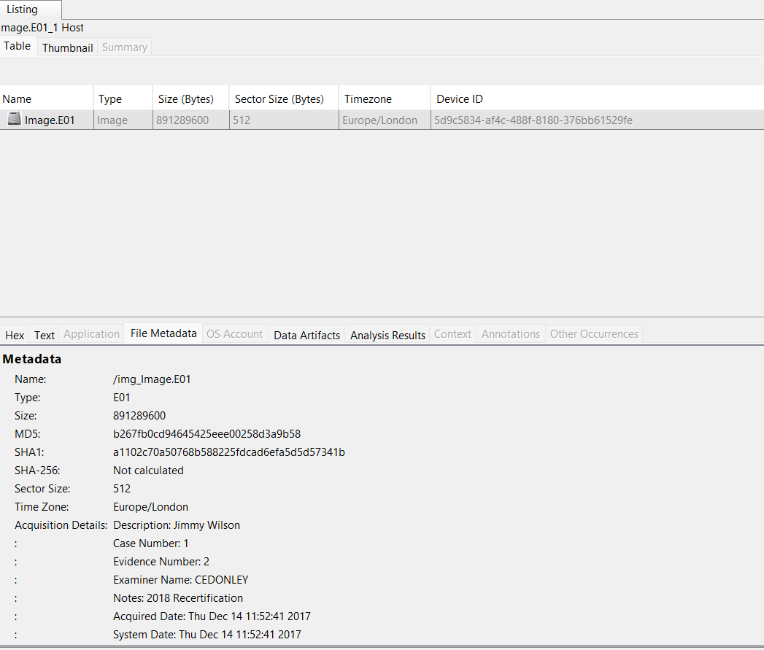
Figure 5 File metadata of the Image.E01
Sector Size
The sector size is explicitly provided as 512 bytes in the metadata.
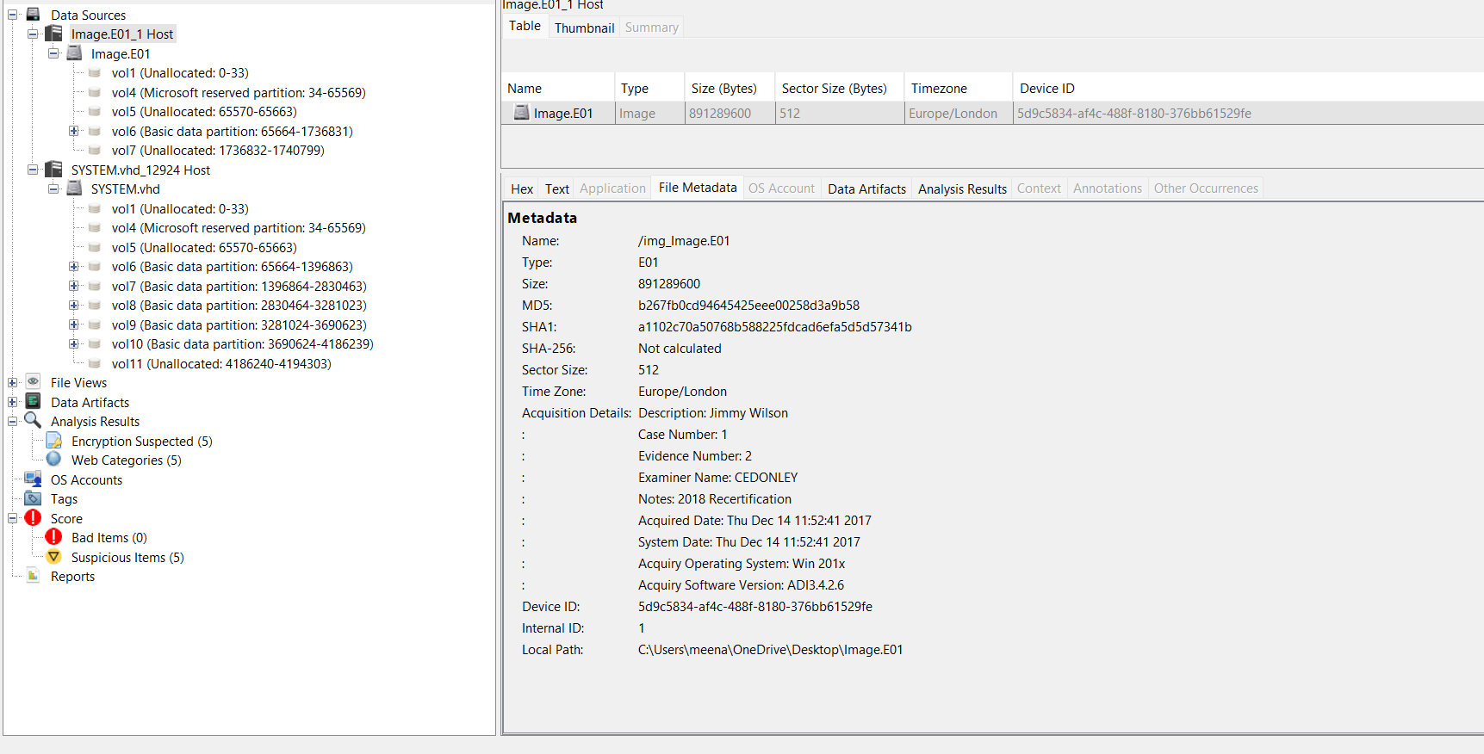
Figure 6 Sector size of the image
Number of sectors:
The total number of sector count is 1,740,800, which is obtained by the AccessData FTK tool of the Image.E01 properties, which is also calculated as:
Total sectors = Disk size / Sector size = 891,289,600 / 512 = 1,740,800 sectors

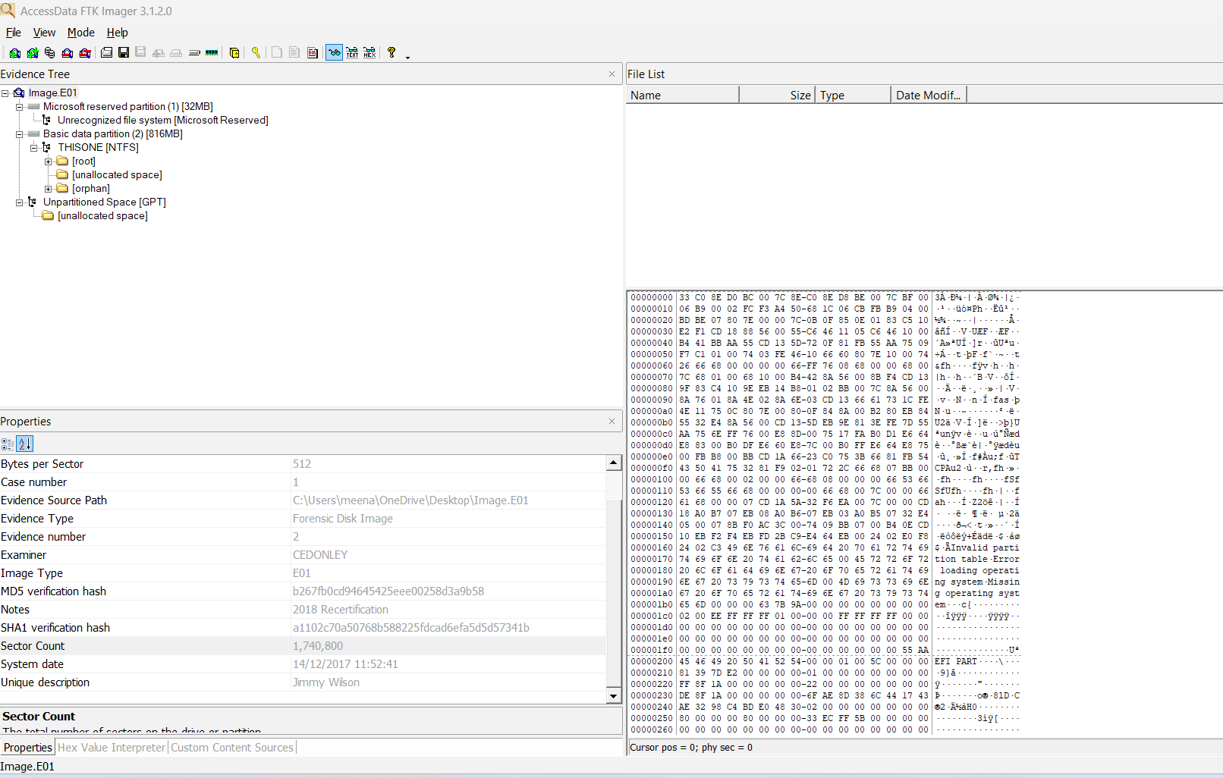
Figure 7 Number of sector - AccessData FTK

Partitioning Scheme
FTK Imager confirms Image.E01 use GPT (GUID Partition Table), evidenced by the "Unpartitioned Space [GPT]" label and "Basic data partition [NTFS]" entries in the Evidence Tree.
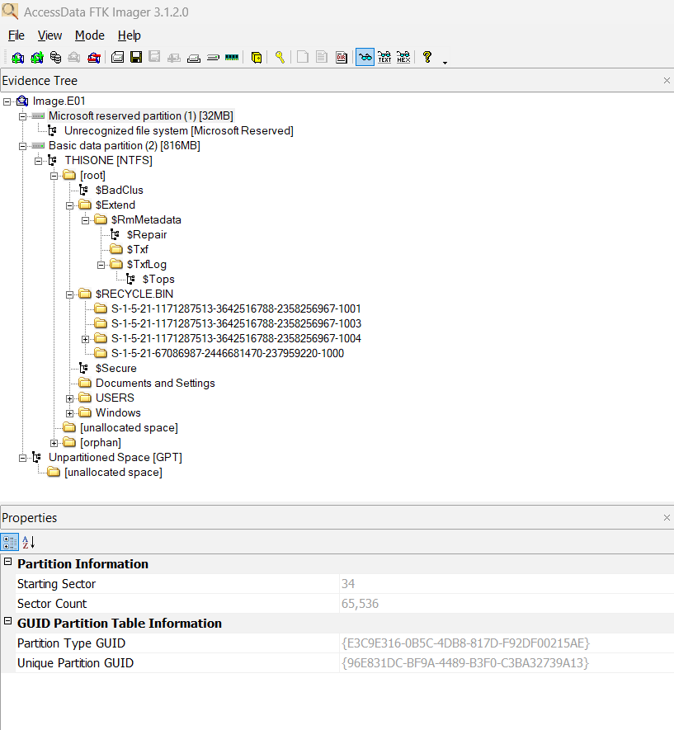
Figure 8 Evidence Tree — Image.E01 partitions
Number of Partitions
Autopsy is used for volume-level detail. Image.E01 contains 5 volumes (vol1–vol7, with vol1, vol5, and vol7 being unallocated gaps). The two true partitions are vol4 (MSR – Microsoft Reserved Partition) and vol6 (basic data / NTFS). SYSTEM.vhd, which is obtained by running the ingest module Recent activity contains 9 volumes (vol1–vol11), of which vol4 is MSR, vol5/vol11 are alignment gaps, and vol6–vol10 are five active data partitions.
Partition Size
Autopsy identifies five volumes in Image.E01. Vol1 (17,408 bytes) and Vol5 (48,128 bytes) are unallocated alignment gaps. Vol4 is the 32 MB Microsoft Reserved partition, containing no file system. Vol6 is the primary basic data partition, sized at 4,096 × 208,895 blocks = ~816 MB, formatted as NTFS with volume label THISONE. Vol7 (2,031,616 bytes) is the GPT backup region.
Partition Location
Partition locations are mentioned in the diagram [ Figure 9]

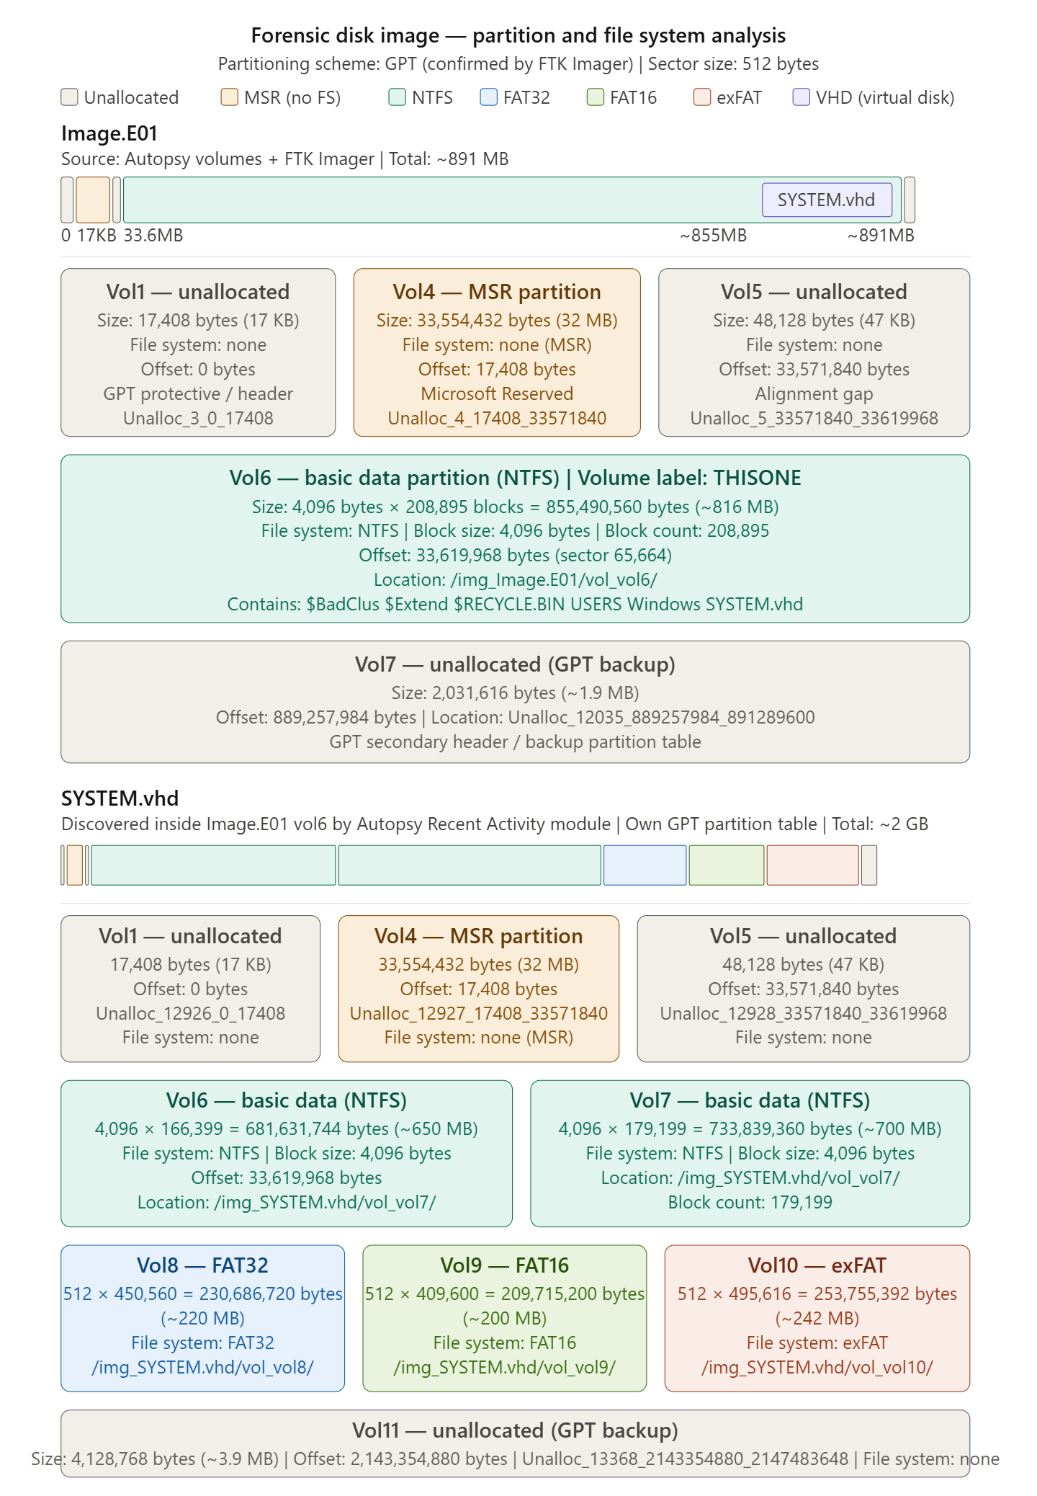
Figure 9 Forensic disk image — partition and file system analysis
File system types within partition:
FTK Imager identifies the file system: vol6 of Image.E01 contains NTFS - Windows XP (NTFS 3.1) (label: THISONE). The MSR volumes contain no user-accessible file system and are labelled "Unrecognized file system [Microsoft Reserved]" by FTK.
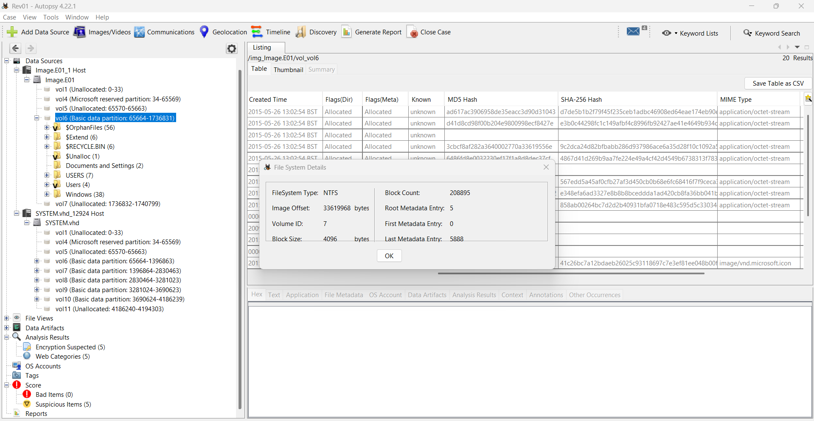
Figure 10 Vol 6 Partition - File System - NTFS

The correct time zone of the Image.E01 is identified by Registry Explorer (Figure 11), which confirms the time zone by navigating to ControlSet001 → Control → TimeZoneInformation. The key values reveal Bias = 300 and ActiveTimeBias = 300. A bias of 300 minutes subtracted from UTC gives UTC−5, identifying the system time zone as Eastern Standard Time (EST).
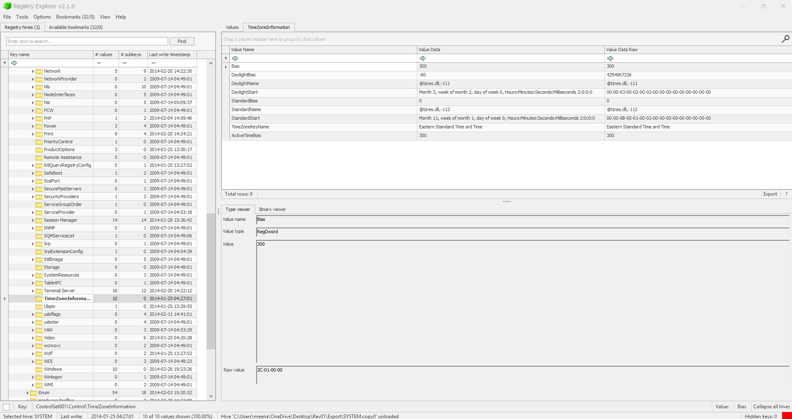
Figure 11 Registry Explorer v2.1.0 showing TimeZoneInformation key
Autopsy (Figure 12) confirms this finding. The TimeZoneInformation key visible in the Data Artifacts panel explicitly shows TimeZoneKeyName = Eastern Standard Time, Bias = 300, and ActiveTimeBias = 300, confirming EST at the point of imaging.

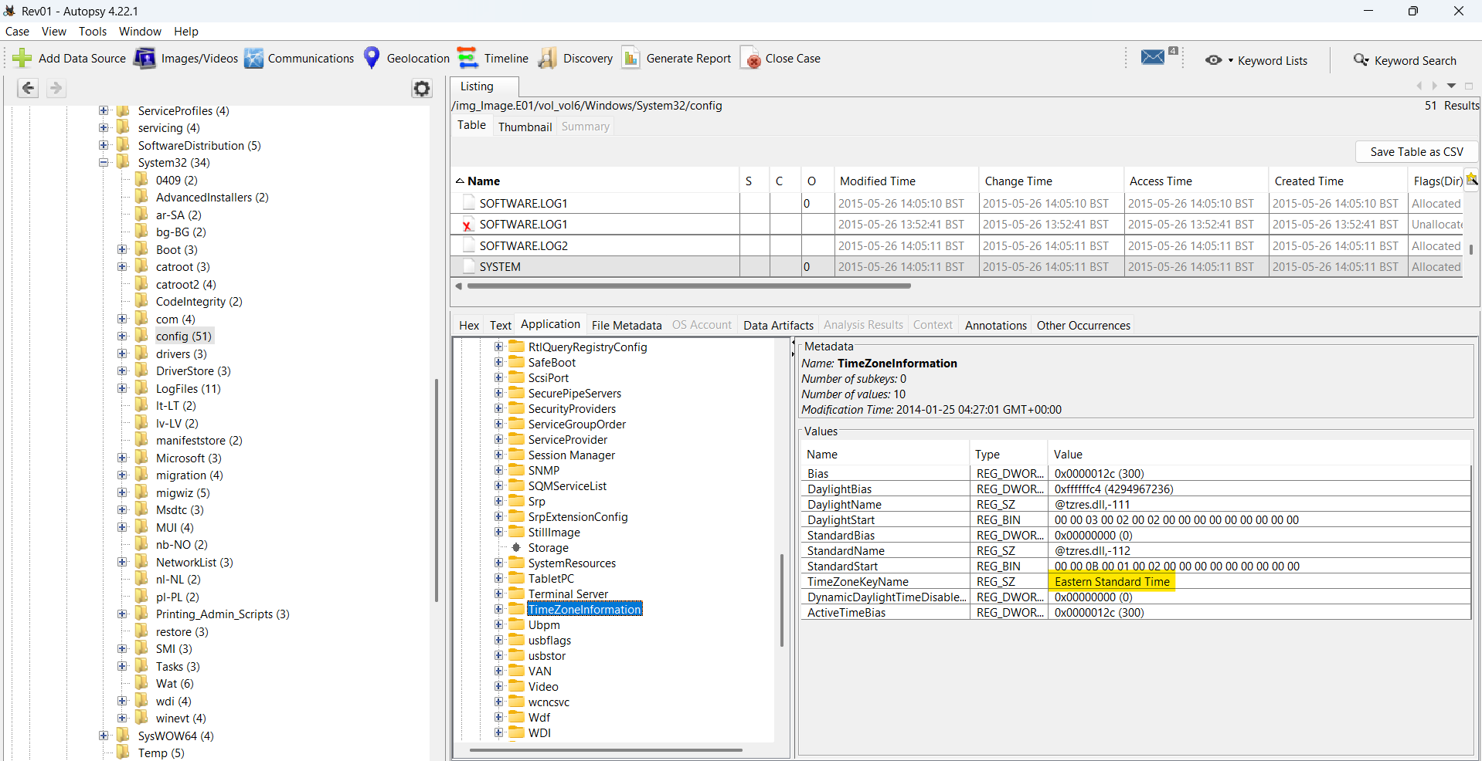
Figure 12 Autopsy v4.22.1 Data Artifacts panel showing TimeZoneInformation registry key
Daylight saving assessment. The DaylightBias value shown in both Registry Explorer and Autopsy is −60, meaning the system was configured to apply a one-hour DST shift when applicable. However, ActiveTimeBias = 300 matches the standard Bias exactly, confirming that DST was not active at the point of imaging. All timestamps should be interpreted as UTC, equivalent to EST (UTC−5) local time.
Operating System Identification
Autopsy identified Windows 7 Ultimate Service Pack 1 (64-bit) installed on the image. This was determined through the Recent Activity module, which analyses the Windows Registry SOFTWARE hive automatically. As shown in Figure 13, the extracted fields confirm the OS name, architecture (AMD64), owner (BillyBob), and hostname (IACIS-HDD-2014).
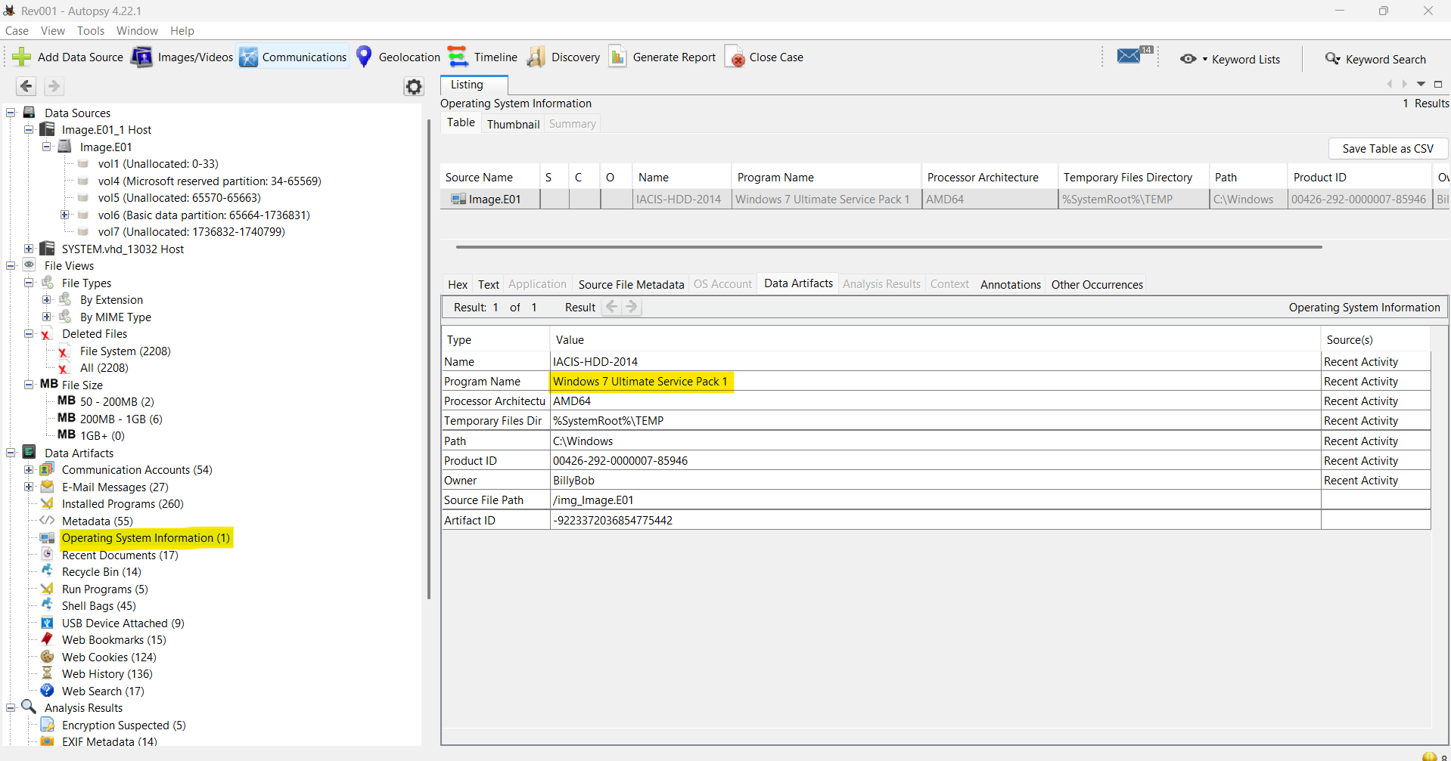
Figure 13 Autopsy OS Details panel
To verify this independently without leaving Autopsy, the raw SOFTWARE hive was manually browsed via Data Sources → Image.E01 → Windows → System32 → config → SOFTWARE, navigating to Microsoft\Windows NT\CurrentVersion, confirming ProductName, and build details Figure 14.
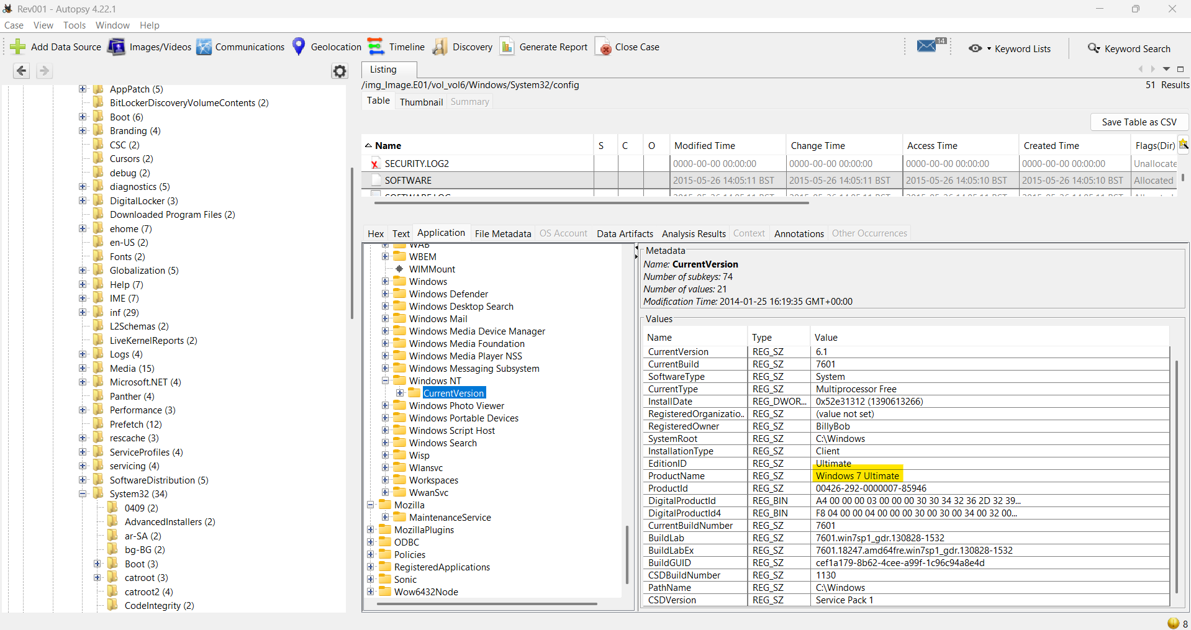
Figure 14 Registry Viewer showing CurrentVersion key
Installed Software
The 260 software programs were installed in the image revealed Installed Programs artifacts [Figure 15]:
- Mozilla Firefox 27.0 (installed 2014-02-05) – potential browsing history and downloads
- Skype 6.13 (installed 2014-02-04) – communications and file transfer logs
- OpenOffice 4.0.1 (installed 2014-02-11) – document creation
- Microsoft Security Essentials (installed 2014-01-25) – antivirus that may have deleted relevant artefacts
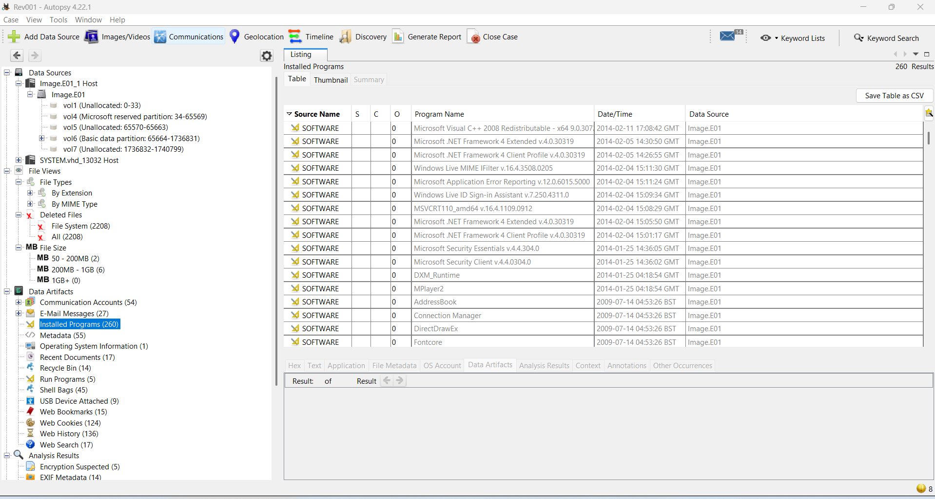
Figure 15 Installed Programs CSV/table in Autopsy
The prefetch files verified in FTK Imager (Windows/Prefetch/) confirm program execution. However, the SID S-1-5-21-67086987-2446681470-237959220-513 you mentioned is a group SID (513 = Domain Users), not an individual user account — so it cannot be attributed to a specific user.
Execution is most accurately attributed to billybob (SID ending -1001) as the primary local user account, validated by the prefetch files visible in FTK Imager dated 26/05/2015.
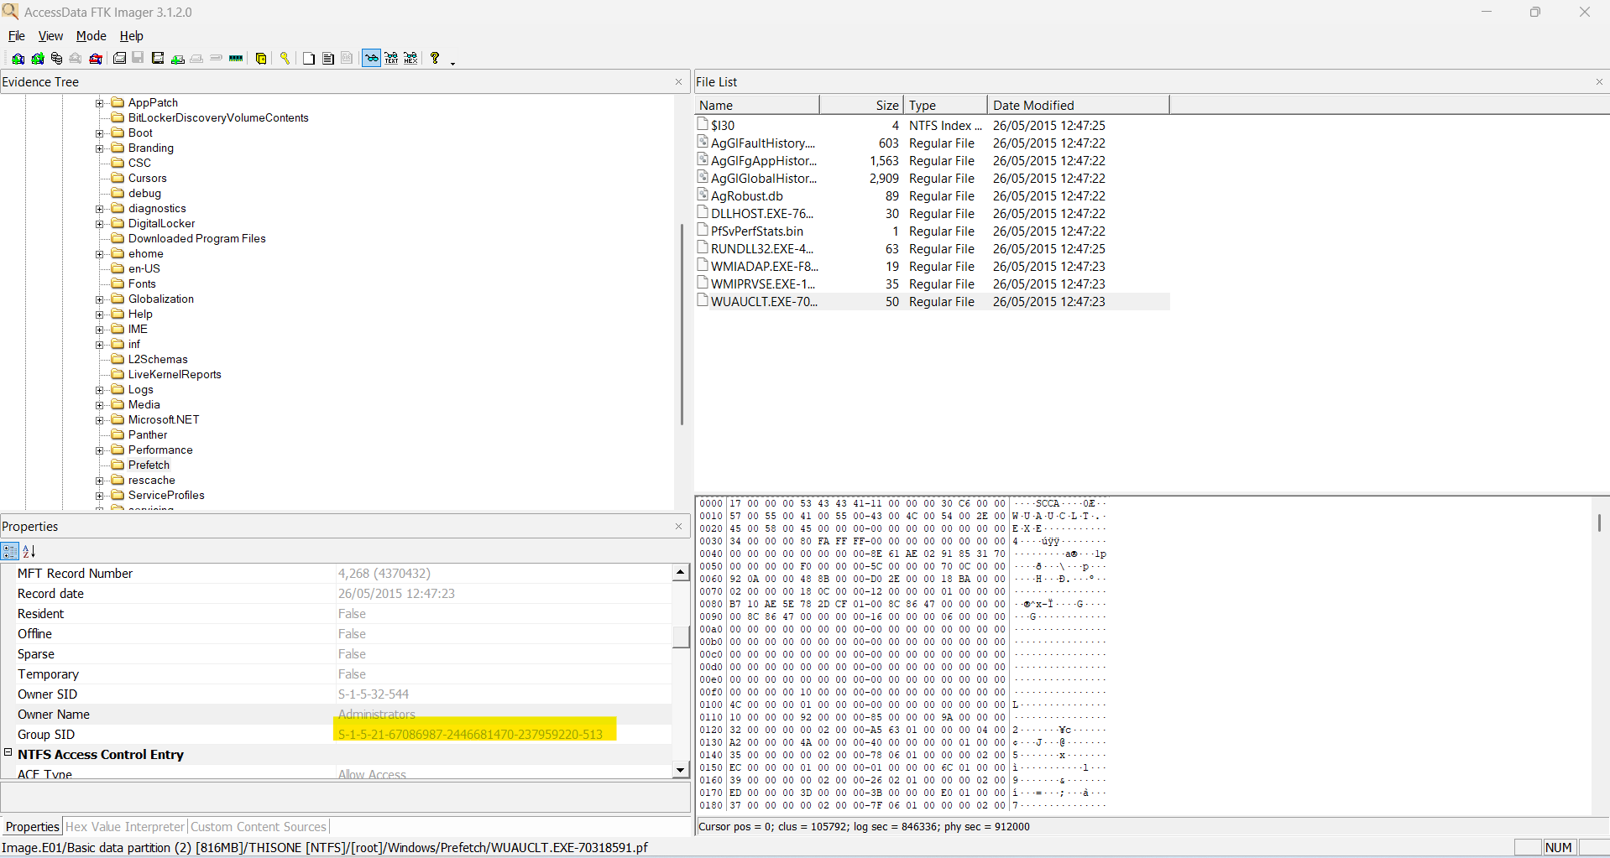
Figure 16 FTK Imager Prefetch folder contents confirming program execution

Hardware Devices and Volumes
In USB Device Attached module, nine devices were identified as having been connected to the forensic image (Image.E01), sourced from the Windows Registry SYSTEM\CurrentControlSet\Enum\USBSTOR hive.
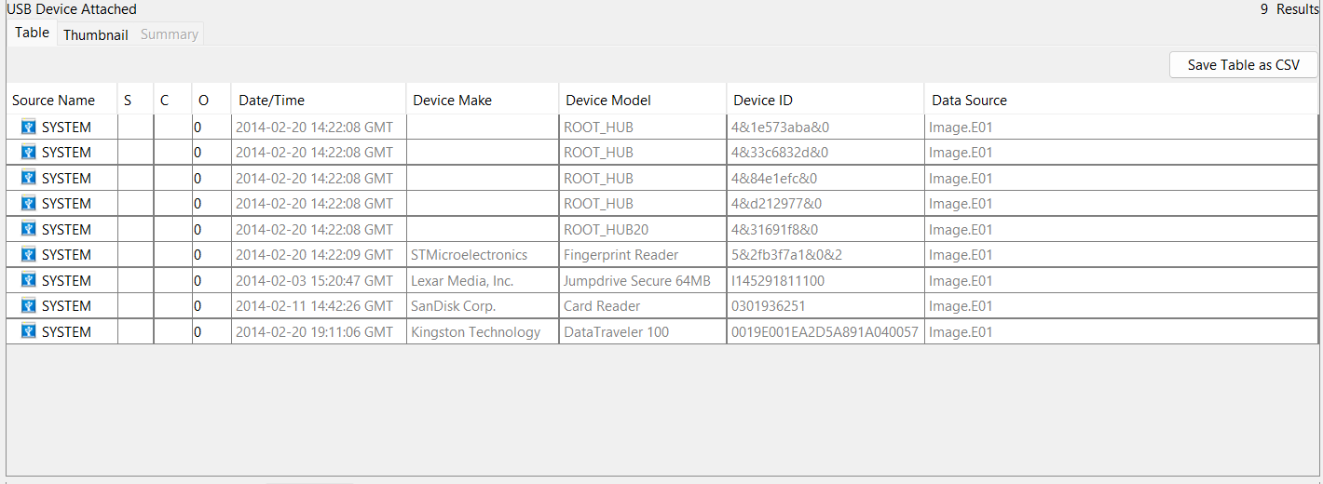
Figure 17 Autopsy USB Device Attached Module
Three forensically significant storage devices were identified: a Lexar Media Jumpdrive Secure 64MB (Serial: I145291811100, connected 2014-02-03 15:20:47 GMT), a SanDisk Card Reader (Serial: 0301936251, connected 2014-02-11 14:42:26 GMT), and a Kingston Technology DataTraveler 100 (Serial: 0019E001EA2D5A891A040057, connected 2014-02-20 19:11:06 GMT). An STMicroelectronics Fingerprint Reader was also identified, connected 2014-02-20 14:22:09 GMT.
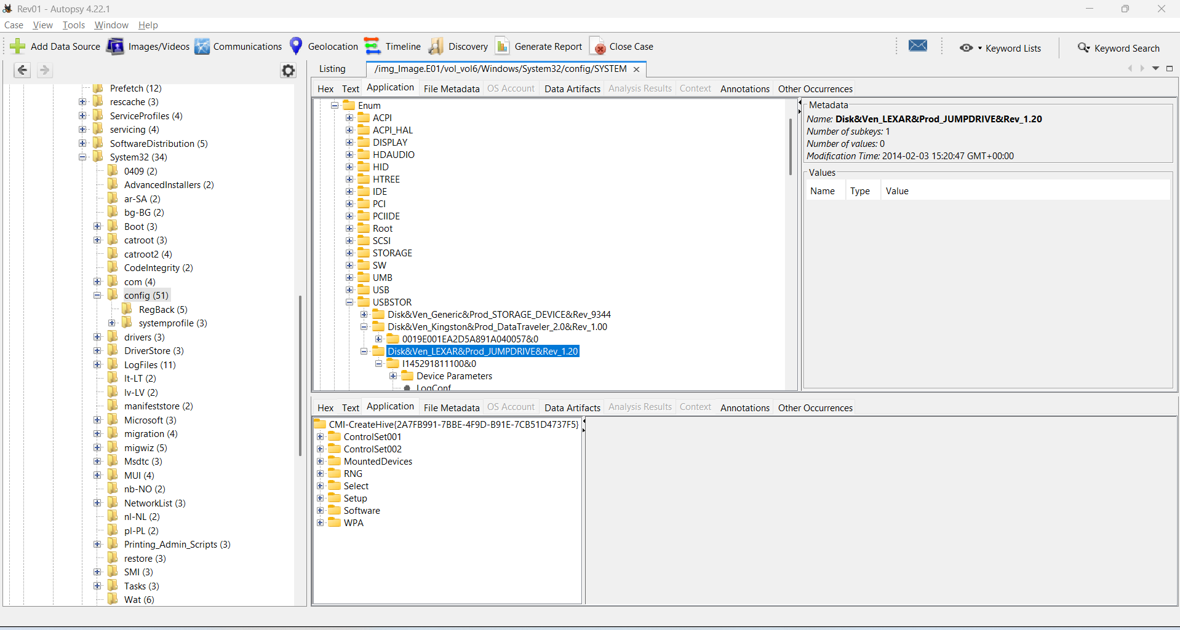
Figure 18 USBSTOR Registry
The Windows Portable Devices registry key confirmed all three storage devices were recognised and assigned drive letters by Windows.
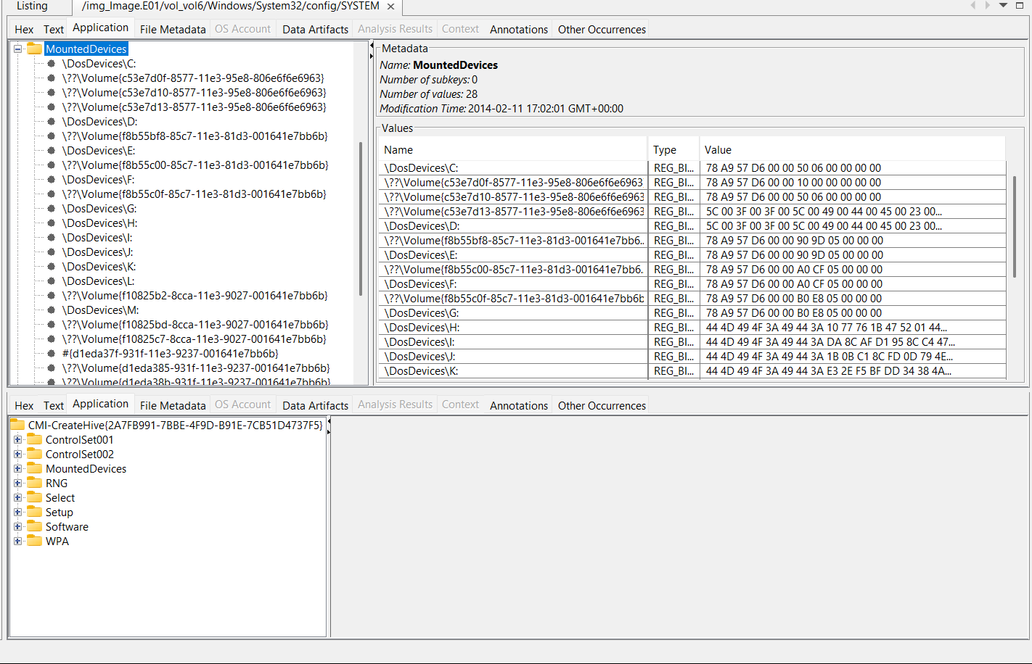
Figure 19 Mounted devices

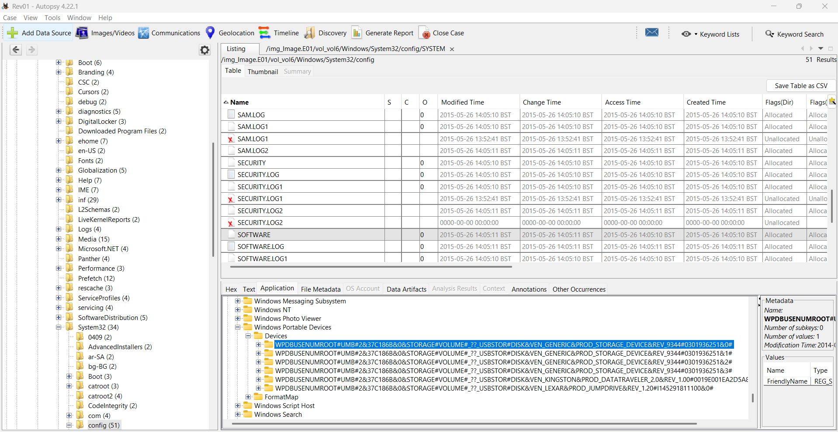
Figure 20 Windows Portable Devices
Regarding who was logged in, the OS Accounts module identified billybob (SID: S-1-5-21-...-1001) as the primary account created 2014-01-25, predating all USB connections. Cross-referencing the USERS directory confirmed jimmy wilson as the only other account with an original 2014 creation timestamp, making these two users the most likely candidates active during device connections.
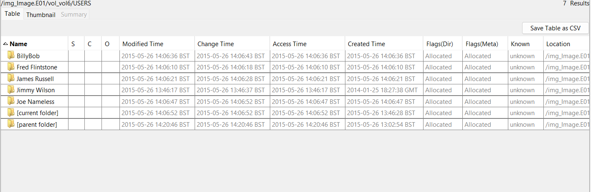
Figure 21 Users

Users and Their Profiles
The OS Accounts module identified seven accounts on Image.E01, sourced from the SAM registry hive. The USERS directory confirms active profiles for BillyBob, Fred Flintstone, James Russell, Jimmy Wilson, and Joe Nameless.


Figure 22 Users
Users Actively Used the System
Jimmy Wilson user with an original profile creation timestamp of 2014-01-25 18:27:38 GMT, confirming genuine pre-acquisition activity. All other profiles show 2015-05-26 timestamps consistent with the forensic acquisition date based on NTUSER.DAT activity, Prefetch, Web history activity.
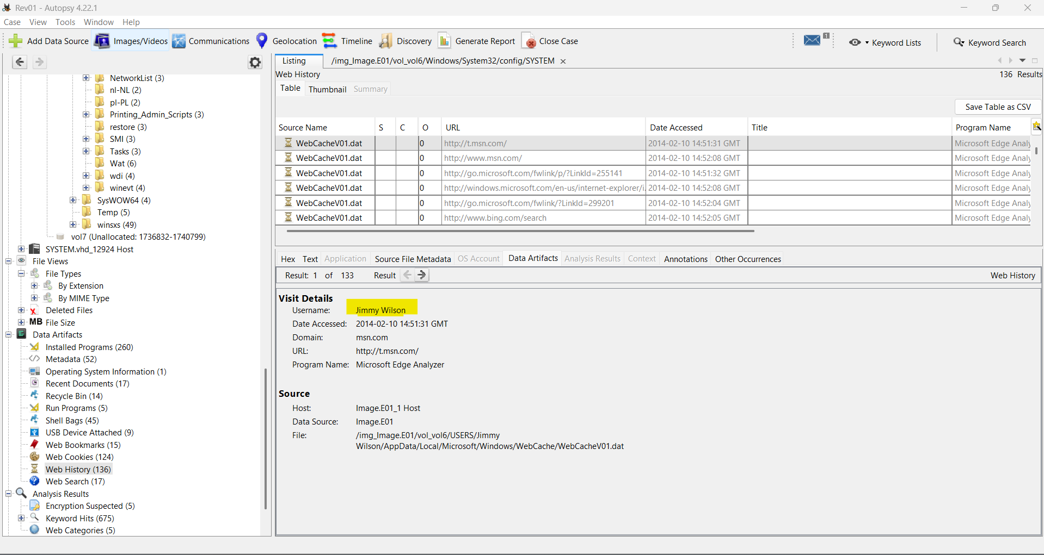
Figure 23 Web History table showing Jimmy Wilson's attributed browsing
Disabled Accounts
As per the OS account, Administrator and guest accounts showed explicit disabled flags from available artifacts.
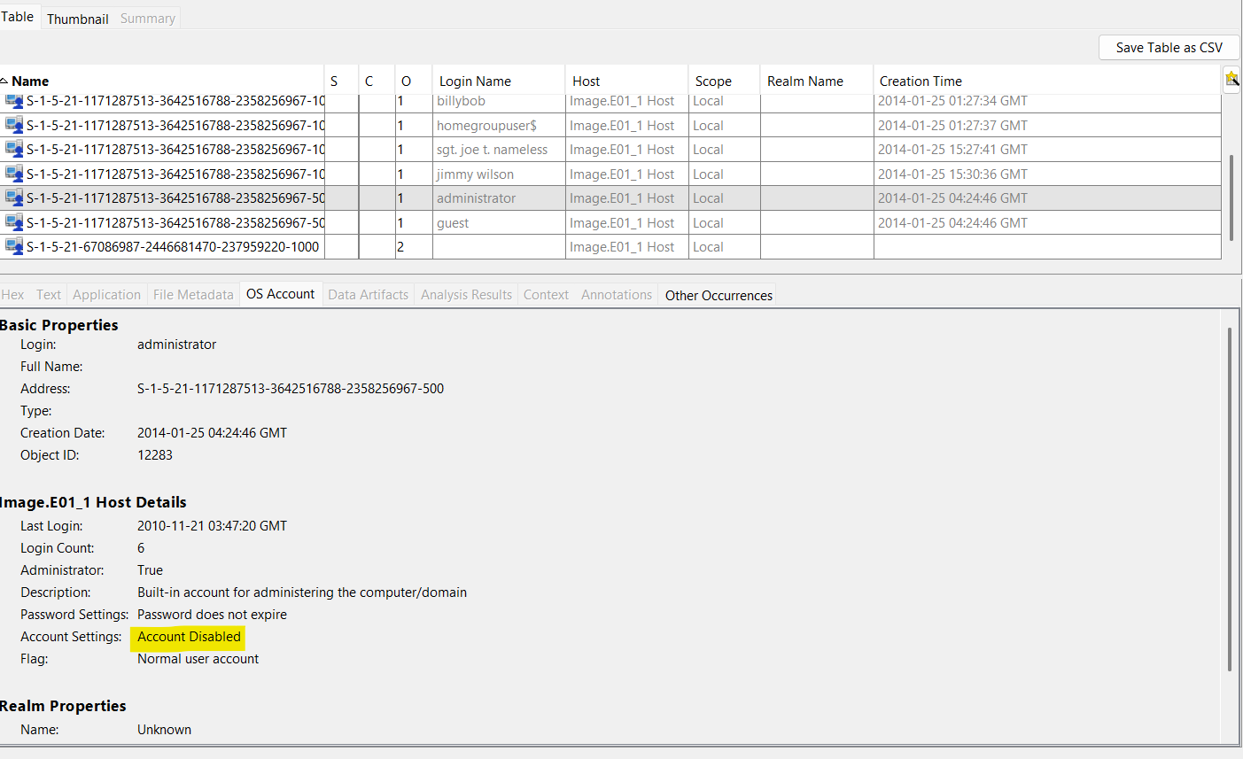
Figure 24 Administrator Account disabled
User Privileges
From the OS Accounts module, the O column and account details confirm the following privilege levels:
The users BillyBob, Sgt Joe t.nameless, Jimmy Wilson have administrator privilege and HomeGroupUser$ is flagged as Normal user account.
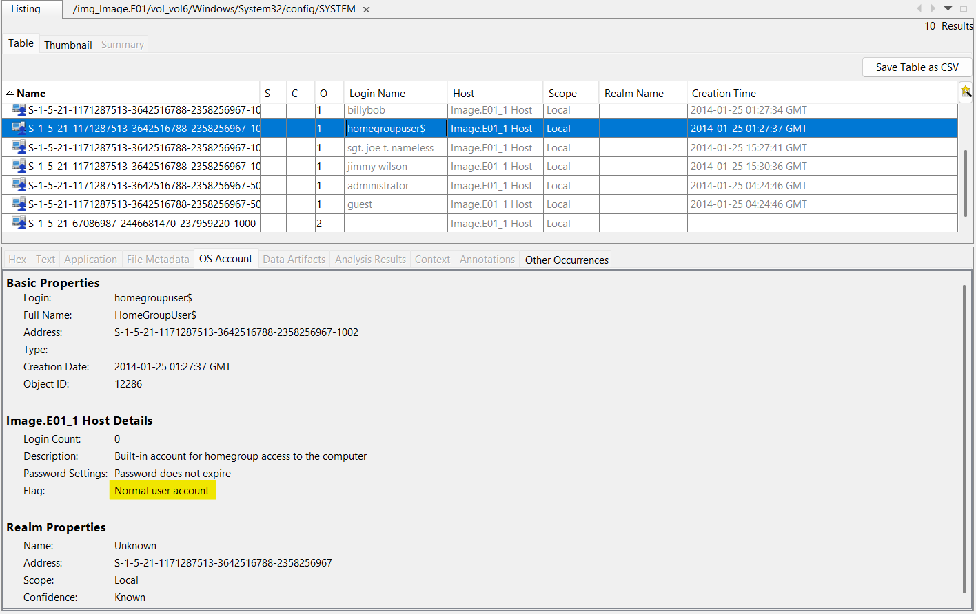
Figure 25 User Privilege
User Activities and File Attribution
Jimmy Wilson — Shell Bags from NTUSER.DAT show desktop items including Skype, Firefox, OpenOffice, Adobe Reader, BCTextEncoder.exe, and folders named "Jose Badguy" and "Robert Ripoff", accessed 2014-02-16. The presence of BCTextEncoder — an encryption tool — alongside named individual folders is forensically significant.
Computer Owner
The Operating System Information module confirms the registered owner as BillyBob, hostname IACIS-HDD-2014, Product ID 00426-292-0000007-85946, sourced directly from the Windows Registry via Autopsy's Recent Activity module.
The email activity is retrieved using the Email parser module in the Autopsy tool.
Main suspect:
The main suspect is Jimmy Wilson (wilsonjimmy807@gmail.com), based on high number of communications in all email exchanges found within Image.E01. The Gmail account was newly created on 2014-02-16, confirmed by Google welcome emails received the same day, determined via Autopsy's E-Mail Messages (27 results) and Communication Accounts modules.
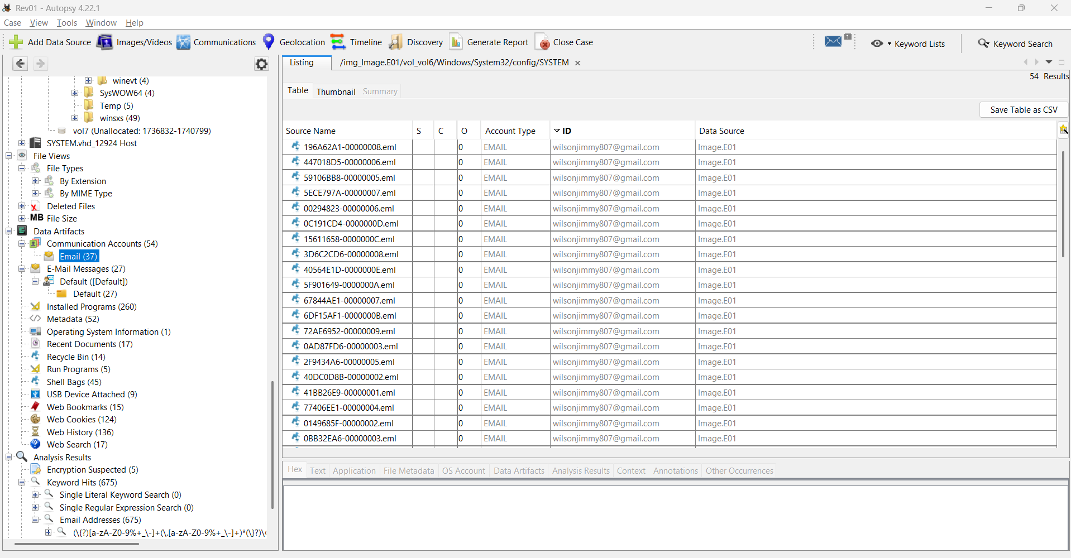

Figure 26 Communication Accounts showing all identified email addresses
Communications with Contacts
Jimmy Wilson communicated with two individuals on 2014-02-16:
Robert Ripoff (robert.ripoff@gmx.com) — 12 emails, multiple with attachments. Robert contacted Jimmy with a new email address stating he needed "items made", requesting orders be sent as BCTextEncoder encrypted files using a pre-agreed password.
Jose Badguy (jose.badguy@hushmail.com) — 11 emails, multiple with attachments. Jimmy confirmed he was operational, instructed Jose to send encrypted orders via BCTextEncoder, and sent his price list as an attachment, which Jose accepted.
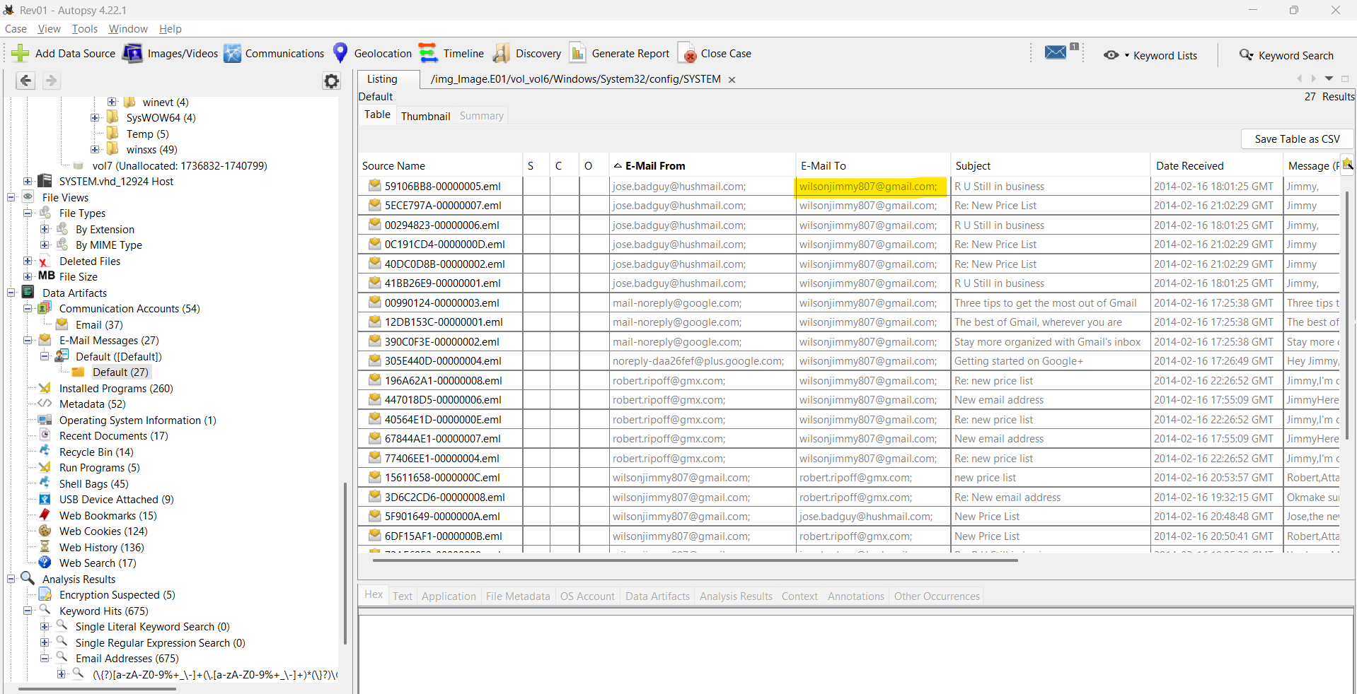
Attachments
Of 27 emails, 14 contained attachments — predominantly the encrypted price list and encrypted order files sent between all three parties.
Suspect Relationships and Content Summary
Jimmy Wilson operates as a supplier, with Robert Ripoff and Jose Badguy as customers placing orders. The deliberate use of BCTextEncoder encryption, Hushmail (an anonymous email service used by Jose) in the email subject, such as Re: New email address" or "Re: R U Still in business, and a structured price is consistent with patterns observed in organised criminal activity.
Digital Forensic Investigation Methodology
The investigation followed the ACPO Good Practice Guide for Digital Evidence(2012), applying four core principles: preserving evidence integrity, ensuring all actions are auditable, maintaining a documented chain of custody, and using qualified examiners. The forensic image (Image.E01) was examined using Autopsy 4.22.1 without modifying the original evidence. The investigation was structured across five phases: Identification, Preservation, Collection, Examination, and Analysis, consistent with the NIST SP 800-86 Guide to Integrating Forensic Techniques (Kent et al., 2006)
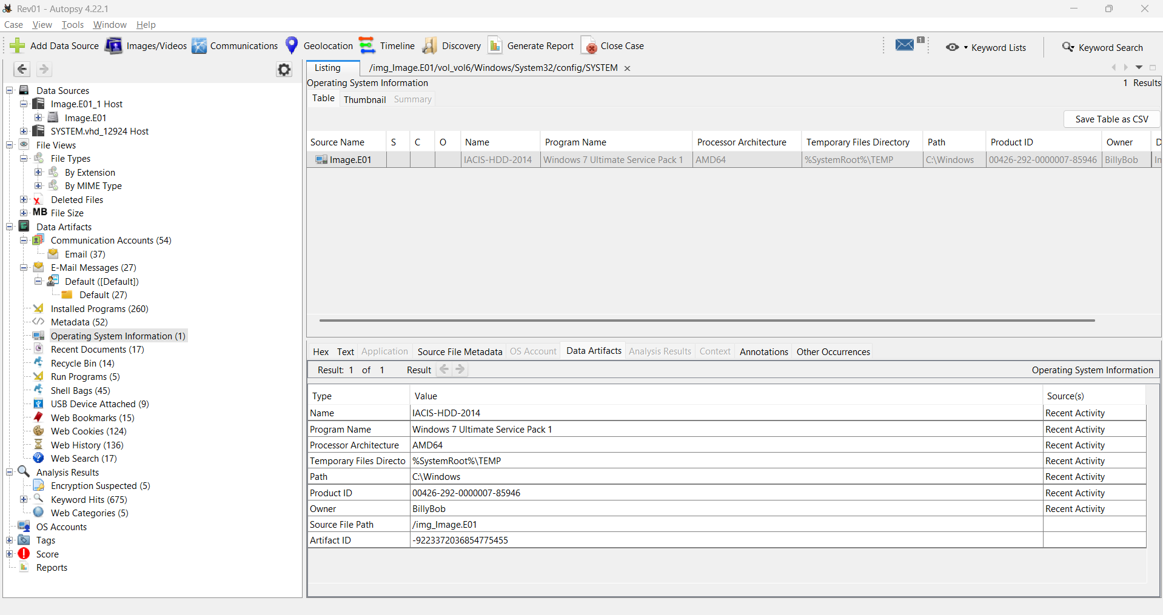
Figure 27 Autopsy case overview showing Image.E01
Additional Findings
Web Browsing Evidence
Web history from places.sqlite (Firefox) and WebCacheV01.dat (Internet Explorer) revealed significant searches on 2014-02-10 and 2014-02-11. The user searched for "handguns" across Google and Bing, searched "how to steal identities" visiting a related lifehacker.com article, then searched "identity theft jail time" — demonstrating direct awareness of the criminal nature of their activities. (Casey, 2011) notes that browser history is among the most valuable sources of investigative intelligence as it directly reflects user intent. Multiple visits were made to zebra.com, specifically the ZXP Series 8 card printer pages, with the technical datasheet downloaded. The user also visited barcodesinc.com browsing ID card printers and a blog titled "How to Hide Money From The Government". Local file access confirmed New Price List Encoded.TXT was opened immediately before being emailed to contacts.
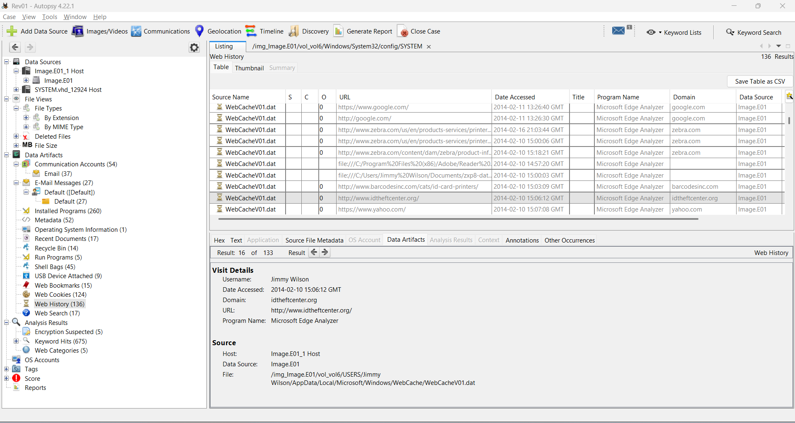
Figure 28 Web History showing identity theft searches
Shell Bags Evidence
Shell Bags from NTUSER.DAT revealed desktop items accessed 2014-02-16, including folders named "Jose Badguy" and "Robert Ripoff", alongside BCTextEncoder.exe and a shortcut named "Jose 42 encoded". Shell Bags are a well-established forensic artefact for proving folder access and user activity (Zeltser, 2011), directly linking this machine to the criminal communications.
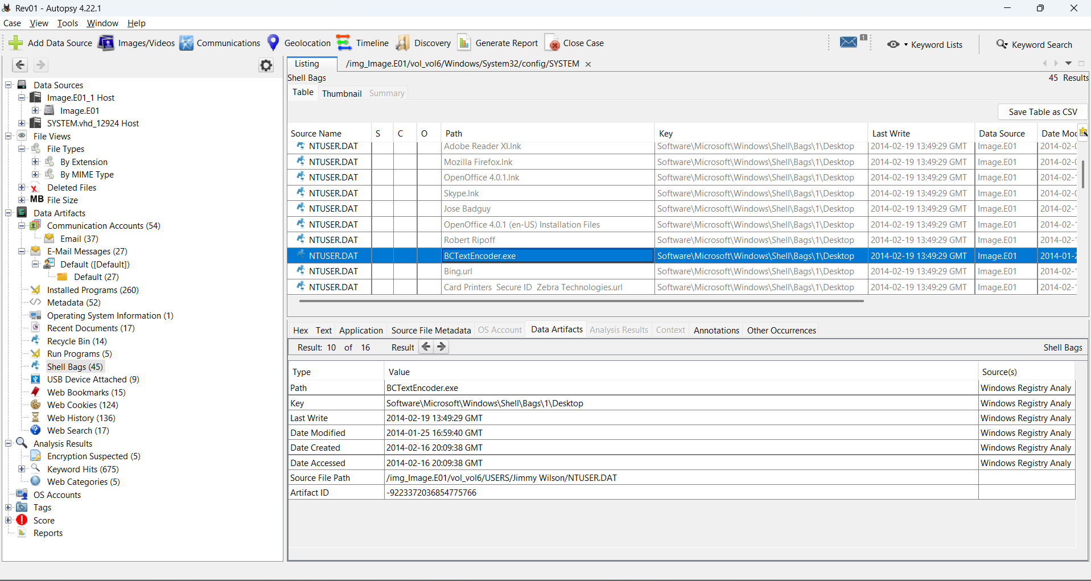
Figure 29 Shell Bags showing named folders and BCTextEncoder
Encryption and Deleted Files
Autopsy flagged five files as Encryption Suspected, consistent with BCTextEncoder usage. (K. K. Sindhu, 2012) describes encryption as a common anti-forensic behaviour intended to obstruct investigation. Additionally, 2,208 deleted files and 14 Recycle Bin items were identified, suggesting deliberate file cleanup warranting further examination.
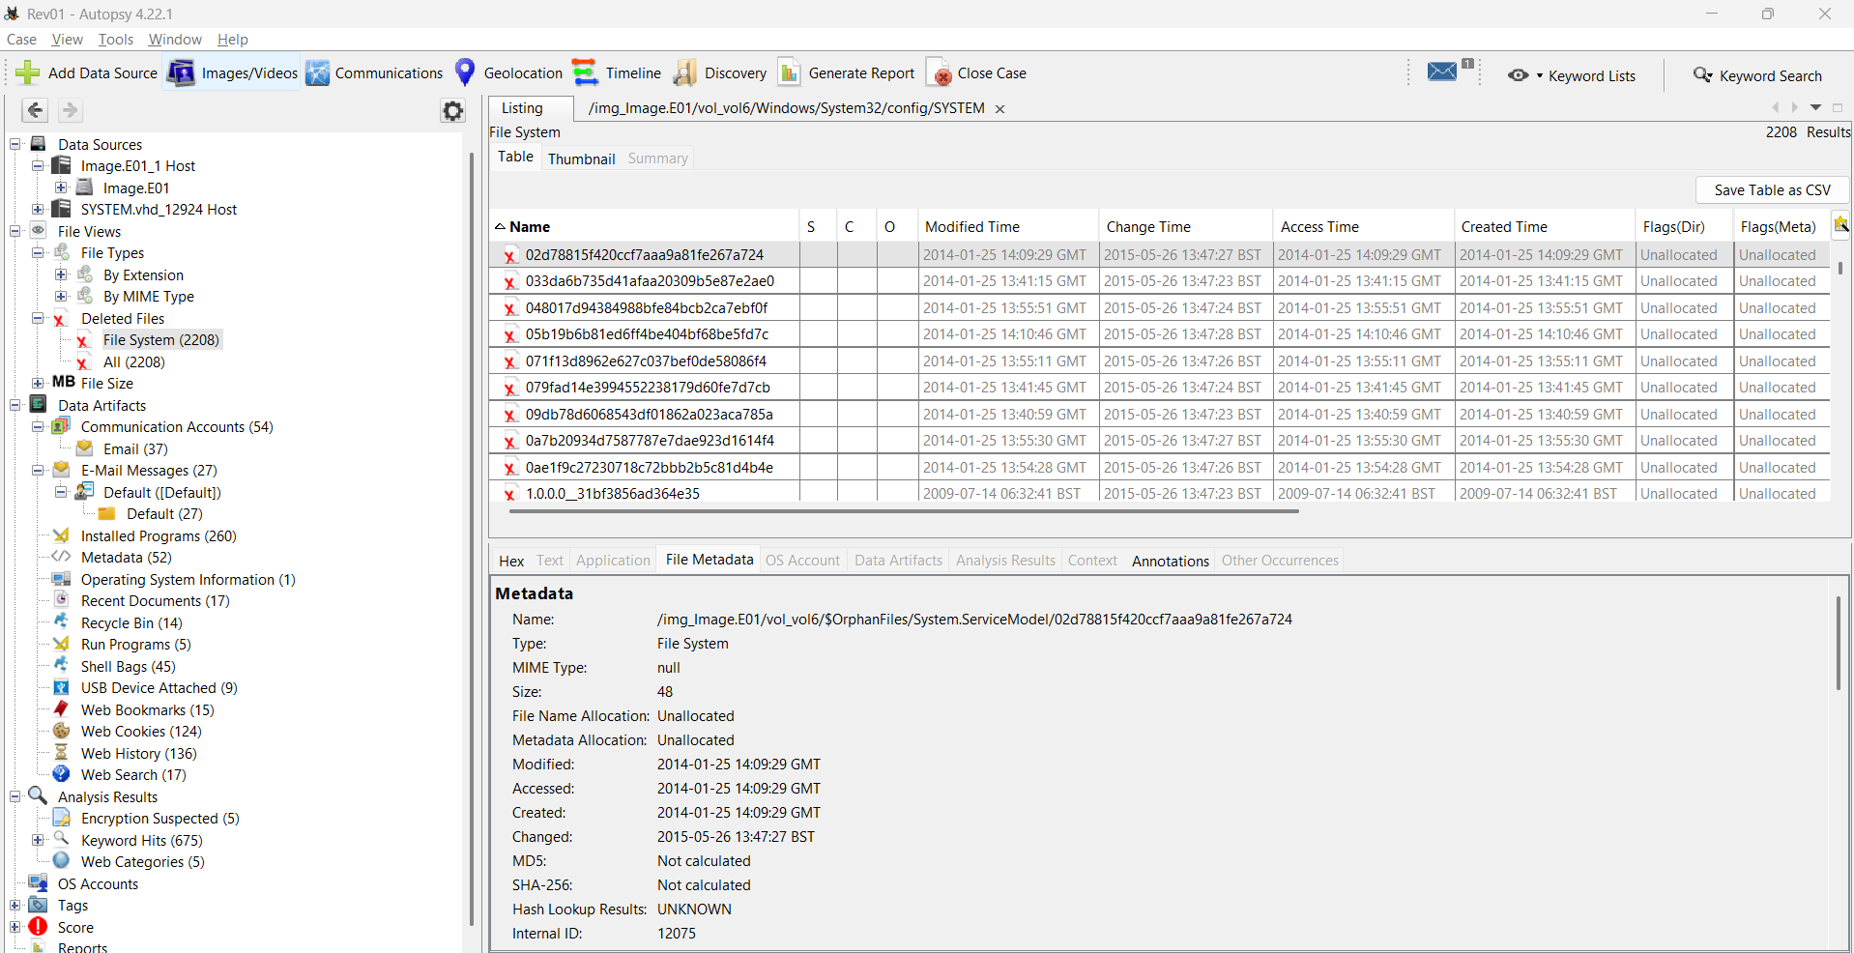
Figure 30 Encryption Suspected and Deleted Files
Conclusions
The investigation reveals strong evidence of an organised criminal operation centred on Jimmy Wilson (wilsonjimmy807@gmail.com), operating from a machine registered to BillyBob (hostname: IACIS-HDD-2014). Evidence strongly suggests Jimmy Wilson was engaged in the production and sale of fraudulent identity documents. Research into the Zebra ZXP Series 8 card printer, combined with a structured encrypted price list sent to Robert Ripoff and Jose Badguy, the use of BCTextEncoder, and Jose's use of Hushmail demonstrate deliberate operational security. Sammes and Jenkinson (2007) note that combined use of encryption and anonymised communication channels is a strong indicator of premeditated criminal conduct. Searches for "identity theft jail time" confirm the suspect's awareness of criminality.

Identified Crimes
1. Conspiracy to Commit Fraud — Coordinated communications between all three parties, contrary to the Criminal Law Act 1977 (HMG, 1977)
2. Possession of Articles for Use in Fraud — BCTextEncoder and encoded price lists, contrary to Section 6 of the Fraud Act 2006 (HMG, 2006)
3. Possible Money Laundering — Contrary to the Proceeds of Crime Act 2002(HMG, 2002)
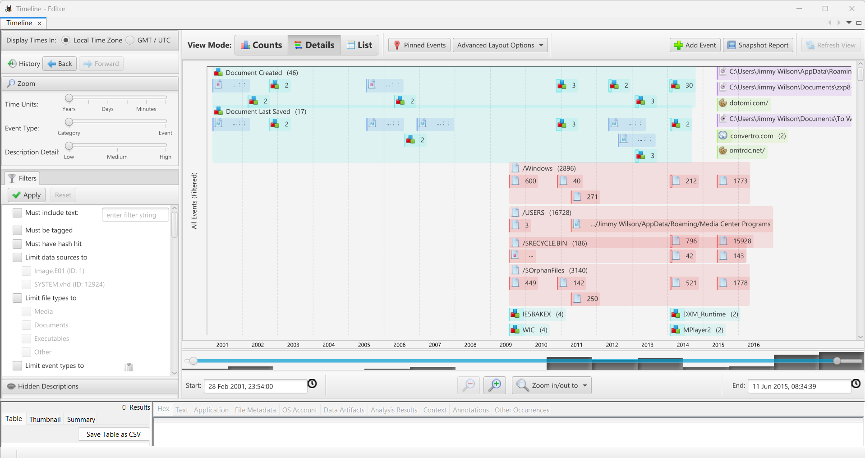
Figure 31 Autopsy Timeline showing activity cluster
- Casey, E. (2011) Digital Evidence and Computer Crime: Forensic Science, Computers, and the ... - Eoghan Casey - Google Books. Available at: https://books.google.co.uk/books?hl=en&lr=&id=lUnMz_WDJ8AC&oi=fnd&pg=PP1&dq=Casey,+E.+(2011)+Digital+Evidence+and+Computer+Crime.+3rd+ed.+Academic+Press.&ots=aMv6AdGSX7&sig=3fdbDiTM0FPpcMv5AwAiMLU2olA#v=onepage&q=Casey%2C%20E.%20(2011)%20Digital%20Evidence%20and%20Computer%20Crime.%203rd%20ed.%20Academic%20Press.&f=false (Accessed: 1 April 2026).
- HMG (2002) Proceeds of Crime Act 2002. Available at: https://www.legislation.gov.uk/ukpga/2002/29/contents (Accessed: 11 April 2026).
- HMG (2006) Fraud Act 2006. Available at: https://www.legislation.gov.uk/ukpga/2006/35/contents (Accessed: 11 April 2026).
- HMG (no date) Criminal Law Act 1977. Available at: https://www.legislation.gov.uk/ukpga/1977/45/contents (Accessed: 11 April 2026).
- K. K. Sindhu, B.B.M. (2012) B. Carrier, “File System Forensic Analysis,” Addison Wesley Professional, 2005. - References - Scientific Research Publishing. Available at: https://www.scirp.org/reference/referencespapers?referenceid=503838 (Accessed: 11 April 2026).
- Kent, K. et al. (2006) ‘Guide to Integrating Forensic Techniques into Incident Response’. Available at: https://doi.org/10.6028/NIST.SP.800-86.
- (2012) ‘ACPO Good Practice Guide ACPO Good Practice Guide for Digital Evidence for Digital Evidence’

